COVID-19 UPDATE September 20, 2020
COVID-19: WHY WE SOCIAL DISTANCE, FREQUENTLY WASH OUR HANDS, AND WEAR FACE COVERINGS
METRIC
The chart below is the running five day average of COVID-19 Cases in Boulder County since the beginning of the Pandemic. The county was slowly coming down from an uptick that is attributed to an increase in social activities around the 4th of July holiday. What happened? The University of Colorado re-opened and thousands of students returned to Boulder. Most of the increase has been attributed to students who live off campus. On September 15th, the Boulder County Public Health Department has issued a letter to off campus students strongly recommending they self-quarantine. The County also has opened two COVID-19 Test Centers one walk up and one drive through. There is no charge for Boulder County Residents to be tested at the centers. More Test Center Information here. Also, see Boulder County Pandemic Data and University of Colorado COVID Dashboard

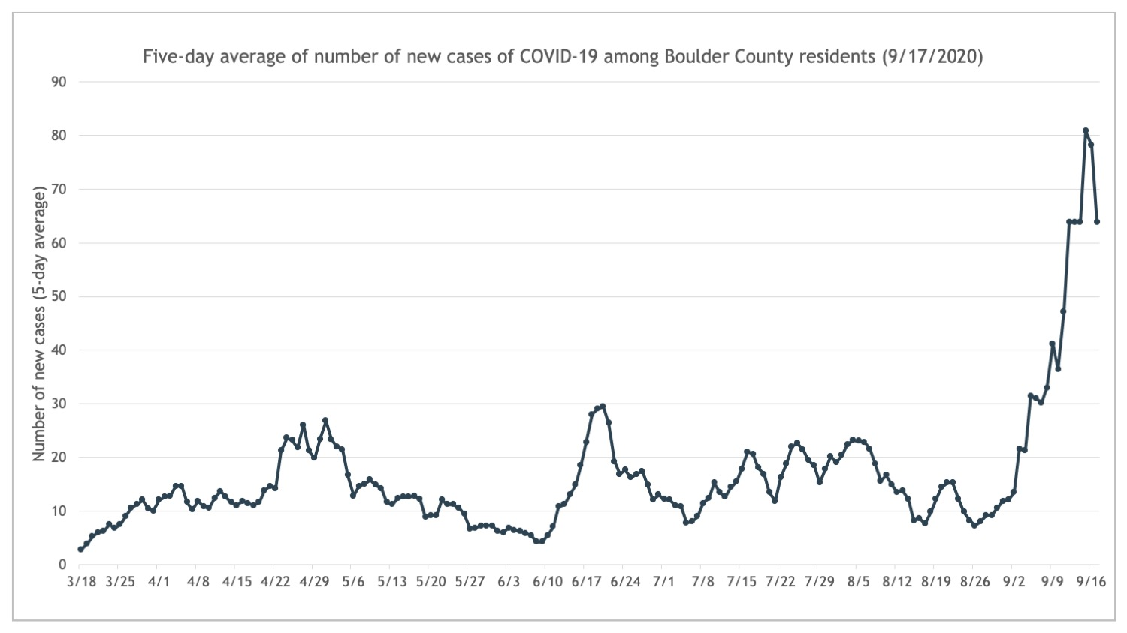

COVID-19: WHY WE SOCIAL DISTANCE AND WEAR FACE COVERINGS
Life has turned upside-down for the human race. Why are we wearing masks, frequently and thoroughly washing our hands, social distancing and avoiding crowds? Why is it so different from other viruses? The chart above indicates that we must, more than ever, protect ourselves by wearing masks, frequently and thoroughly wash our hands, social distance and avoid crowds.
Professor John Campbell, PhD is a retired Nurse Teacher based in England who also teaches in Asia and Africa when time permits. He has created videos to help students to learn the background to all forms of health care. His focus is on the development of open learning resources for nurses nationally and internationally. Professor Campbell is a member of the British Society for Immunology and a formerly an Associate Director for the Scottish National Blood Transfusion Services. John Campbell Bio Since January, Dr. Campbell has been producing YouTube videos about the novel coronavirus.
In the following video Professor Campbell explains how COVID-19 is unique. The entire video is 32 minutes, but he answers the question about how the and why COVID-19 turned into a worldwide pandemic during the first five or six minutes. Video- Well Persons Spreading the Disease
If you don’t care to watch, here is summary of the video;
The COVID-19 virus is most often spread by people who are asymptomatic, that is they do not yet know that they have been infected. Only 16% of adults and 28% of children are truly asymptomatic, the rest will be infected in some fashion. About half of those people will go on to become sick, although it may be a mild case. While other viruses are infectious mainly after a person feels ill and can therefore stay home or otherwise isolate prior to shedding large amounts of the virus, persons with COVID-19 begin shedding the disease in large amounts just prior to becoming ill and particularly during the first few days of feeling ill. It is estimated that about half of all infections are due to persons who do not feel ill and this is the main driver for spread of the disease.
Therefore, we are social distancing, wearing masks, frequently and thoroughly washing our hands, and avoiding crowds.

