Fee Increase for Capital Reserves Funding

How the Water Committee came to this decision
Not long after the flood, the JT Water Utility realized that we have an opportunity to avoid getting trapped, like we did before the flood, with an antiquated failing water system and a miniscule amount of money available to fix it. (For more details see below “What the future will look like if we don’t do this”) We realized that we needed to create a new Capital Reserves Fund.

By the numbers
We are estimating conservatively that in order to have a ~$526K capital reserve replacement fund 20 years from now, we will need to increase the monthly water fee.

 | Previous monthly rate | Increase monthly rate | New monthly rate
1 ba | $57.33 | $9.35 | $66.51
2 ba | $68.65 | $11 | $79.65
3 ba | $79.33 | $12.70 | $92.03
4 ba | $86.67 | $13.90 | $100.53
5 ba | $89.00 | $14.24 | $103.24

The estimate of $526k reserves in 20 years includes:
> Income from increased fees
> Continued annual $2,500 capital reserves input from JT cap reserves tax revenues.
> The $75K capital improvements beginning balance that we now have
> All at a compounded 1.5% interest rate

How Do Our Fees Compare With Others?

As we’ve said many times we have an economy of scale problem. Usually the more customers a utility can draw from to cover its costs, the less it has to charge.
But even with this big disadvantage we’re doing pretty well comparatively:

Utilities that can draw from a much larger customer base sometimes charge more, or about the same, that we plan to be charging
 | Average Monthly fee for water
Jamestown (2 bedroom new fee) | $79.65
Nederland | $80-$100*
Erie | $77**
Colorado Springs | $85**
Thornton | $79**
* obtained from Nederland billing department
**obtained from City of Boulder: in “Rate Increase Info Graphic 2017”

But of course others can charge less

 | Average Monthly fee for water
Greeley | $55*
Louisville | $48*
Boulder | $42*

*obtained from City of Boulder: in “Rate Increase Info Graphic 2017”

The Process We Went Thru to Determine the Fee Increase

What is going to break when?
Our first task was to figure out how soon things are going to break and how much it will cost to fix or replace them. The Colorado Department of Local Affairs (DOLA) was strongly supportive of this. They provided us with numerous staff hours, lots of direction, and, very importantly, a computerized modeling system to handle all of the data we were generating. The Committee spent many hours identifying all the different components of our system – down to the individual pipes – and estimating what the cost and life expectancy of each component would be. Our Water Engineer, Jennifer Aieta; and our plant operators Jon Ashton and Emma Hardy were key in this laborious process.

How much will it cost to maintain our assets?
The Water Utility assets, their life expectancies, what they now cost; all of these things were fed into the DOLA modeling software. This software put it all together, added in inflation, and then estimated our asset costs – year by year – for 40 years into the future!

What Will It Take to Pay For It?
Now we knew what was going to be needed. But what would it take to pay for it? What we needed to know was how much of a reserve we might realistically expect to have over the years, depending on how much we set aside for Capital Reserves from each fee payment cycle. We began by looking at what existing monies could be dedicated to Capital Reserves. Then Chris Kroelick, JT Finance Specialist, created a spreadsheet that could factor in different interest return rates on the reserves, what our beginning balance might be, etc. Thanks to this we were able to see where the Capital Reserves account would be over the next 20 years.

Then the hardest and most painful part
Our last task was the hardest and certainly the most painful. We had many meetings where we explored, debated and honed what would be the least amount of money we could charge in fee increases, and still feel like we were creating a fiscally responsible reserve for the utility. Eventually, we were all satisfied that we had created the best balance we could possibly find between ensuring the future of clean water for our customers while keeping customer fees as low as possible.

How Do We Know That This Money Will Be Safeguarded for Capital Reserves Funding?
At the same time that we’re proposing a fee increase, we are also proposing a “Fiscal Policy” resolution for the Water Utility. It specifies that when we receive fee income the percentage of that money that represents this fee increase will immediately be sequestered away into the Capital Reserves fund. And furthermore, if at the end of the year there are uncommitted funds those will also be put into the Capital Reserves fund.

What does this mean for the future?

Our best present estimate is that in 20 years, approximately $4M will be required to replace all worn out capital assets for the water utility. (This assumes 3% inflation.)

Presently the State of Colorado DOLA department asks for a 50% match for grants to upgrade aged deteriorating water systems. That would leave a match of about $2M.

Our projections suggest that with $526k capital reserves savings available in 20 years, in a moderate-to-worst case scenario, we might imagine that the JT utility will have to come up with approximately $1m in matching funds.
Likely quite a lot less. This is because typically additional grant monies to cover matching funds can be found, project costs can be negotiated, and required amounts for grant matches can often be negotiated.

In the worst case scenario this could mean that in 20 years or so the JT Water Utility would have to float a bond. We are recommending that every 5 years the JT Water Committee reevaluate Capital Reserves funding.

Want To See What the Future Will Likely Look Like If We Don’t Do This? Think Pre-flood 2013.

To understand why we’re doing this, we can flashback to early 2013.

For years we had been fixing leak after leak in our distribution system. This piecemeal approach wasn’t going to work for long – truth is, the distribution system was in danger of catastrophic failure.

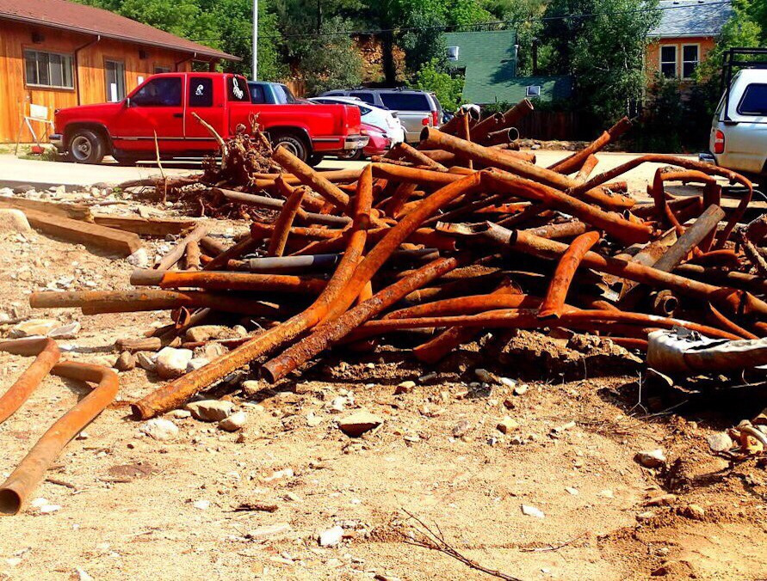
Pre-flood distribution system piping (Photo credit Steve Edelstein)

But this wasn’t the only problem we were facing. There were many others: our pumps were old and breaking, our aged control panels had become unreliable, and the sand filters themselves had way outlived their life expectancy.

We hired Jennifer Aieta, a highly recommended water engineer, to help us assess our needs. After months of research and many discussions with funding sources, we discovered that, to fix even just the most critical needs, we were looking at over a million dollars. Paying for that was going to entail getting grants and also a very large fee increase – estimates for those increases were often in the 60% range. (And that left a lot of pending problems unaddressed – one plan was to ignore the leaking pipes and just focus on the Treatment plan – that alone was going to mean raising fees over 25%.)

Then the September 2013 flood came and severely damaged our whole utility. This tuned out to be a blessing in disguise for the Water Utility: between reimbursement from insurance, aid from FEMA and help from the State of Colorado, we were able to replace almost all of what we needed!

